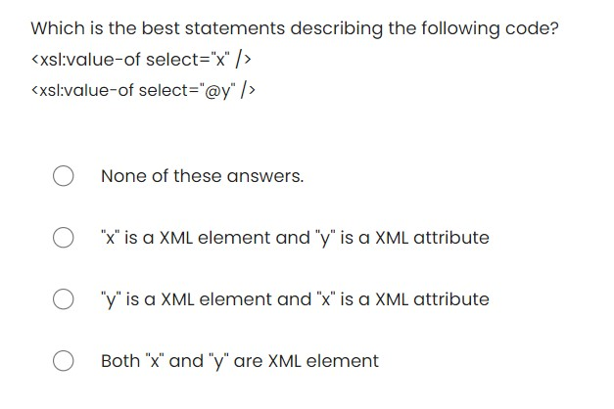

**Answer:"x" is a XML element and "y" is a XML attribute**

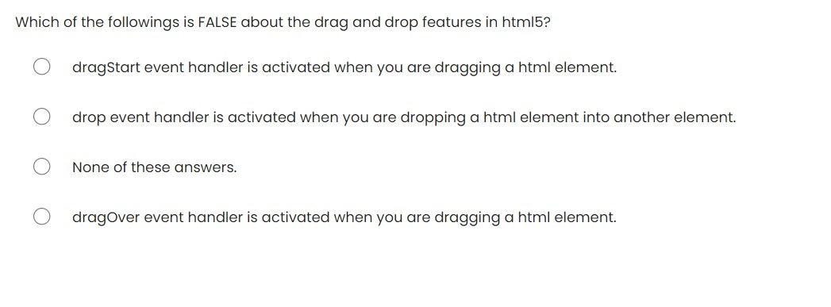

**Answer: dragOver event handler is activated when you are dragging a HTML element.**

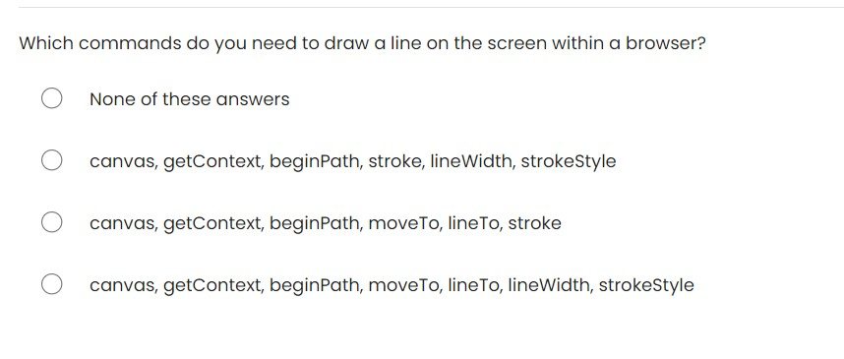

**Answer:** **canvas, getContext, beginPath, moveTo, lineTo, stroke**

Determine what is the range of number which will be generated from the following code. x = Math.floor(Math.random() * 9) + 2

a) from 2 to 10 (inclusive of both end)

b) from 0 to 8 (inclusive of both end)

c) None of these answers.

d) from 1 to 9 (inclusive of both end)

**Answer:** **from 2 to 10 (inclusive of both ends)**

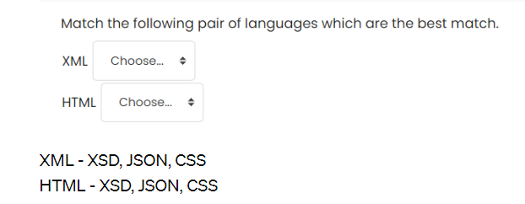

**XML, XSD**

**HTML, CSS**

Determine which of the following statements is TRUE describing the below code. <x y="z">123</x>

a) It can be defined as a simple type in xsd.

b) It is a DTD code defining a xml structure

c)It can be defined as a complex type in xsd.

d) It is a xsd code defining a xml tag with attribute.

**Answer: It can be defined as a complex type in xsd.**

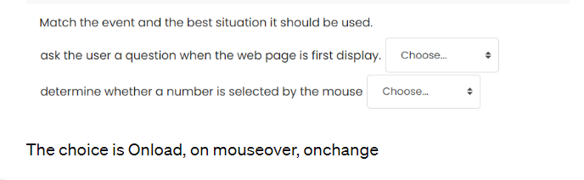

**Answer: Onload, on mouseover**

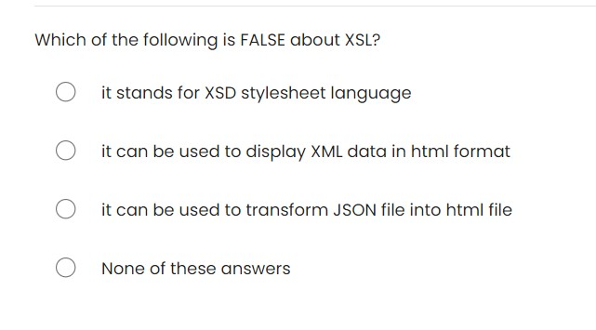

**Answer: it stands for XSD stylesheet language**

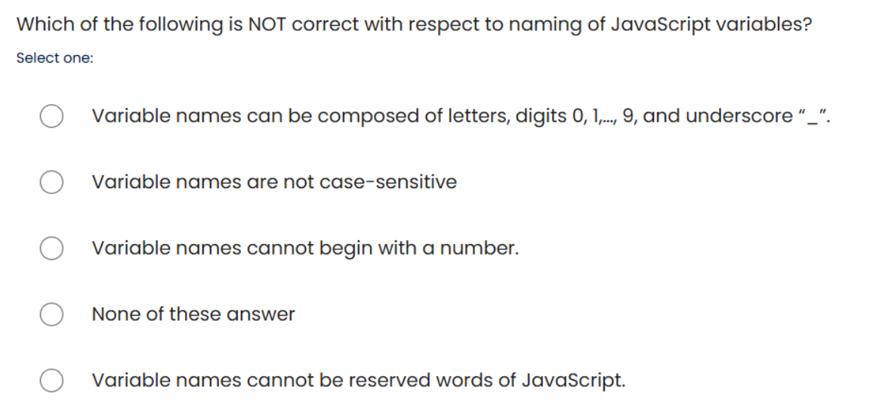

Answer: **"Variable names are not case-sensitive."**

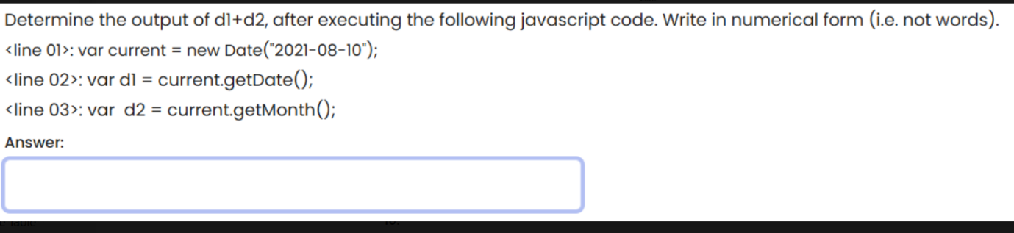

**17**

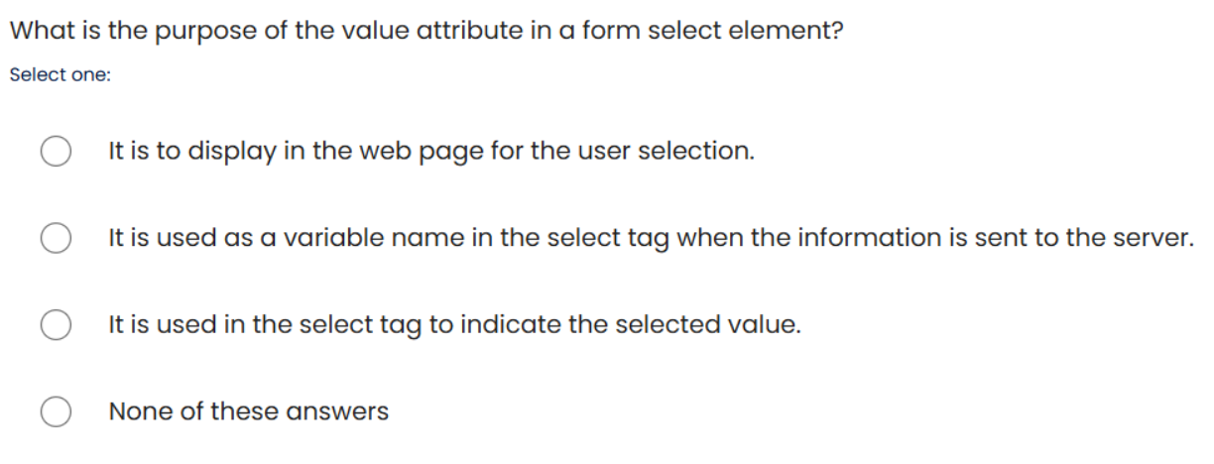

**Answer: "It is used in the select tag to indicate the selected value."**

**which of the following best describe the target attribute?**

**target attribute describe the address of the link? Wrong**

**the target attribute referring to the target length of the input? Wrong**

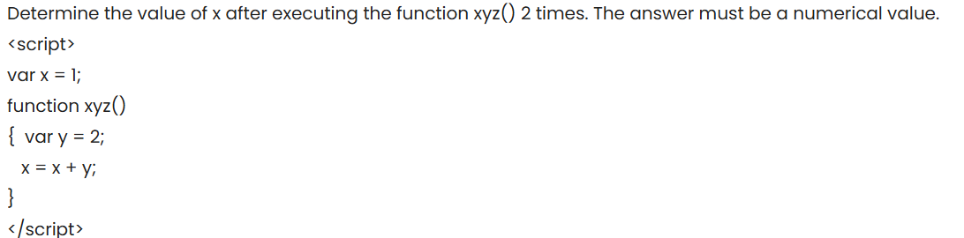

Every time the function xyz() is called, the following happens:

A local variable y is set to 2.

The global variable x is incremented by 2.

Initially, x is 1. Let's determine the value of x after calling xyz() twice:

First Call to xyz():

x is 1 initially.

After executing x = x + y, where y is 2, x becomes 1 + 2 = 3.

Second Call to xyz():

x is now 3.

After executing x = x + y, where y is 2, x becomes 3 + 2 = 5.

So, the value of x after executing the function xyz() two times is **5**.